SMART SHOP

SCHEMA DIAGRAM:

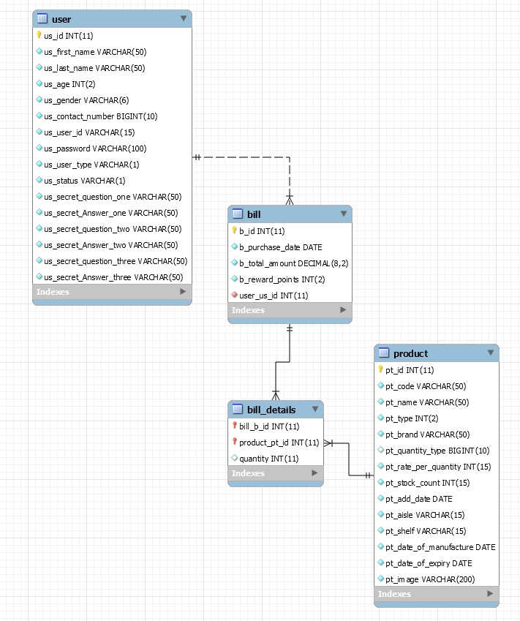

SEQUENCE DIAGRAM:

